Kotarpur Water Treatment Plant Visit

On April 3rd, 2025, Civil Engineering Department arranged a technical visit to Kotarpur Water Treatment Plant as a part of Environmental Engineering curriculum for 6th semester students with faculty coordinators Prof. Ujas Pandya and prof. Shilpa Parmar. It is vital facility located just outside Ahmedabad that plays a crucial role in supplying safe, potable water to a significant portion of the city's population. The primary purpose of our visit was to gain a comprehensive understanding of the intricate processes involved in water purification, from raw water intake to its final distribution. The visit was an eye-opening experience, offering a detailed look into the sophisticated engineering and meticulous procedures that ensure the quality of our daily water supply.
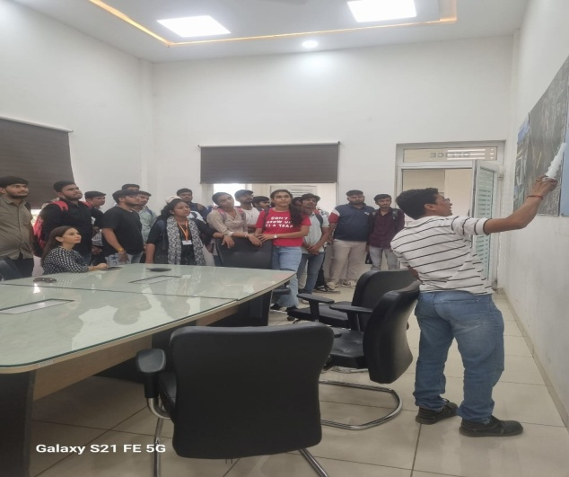 | 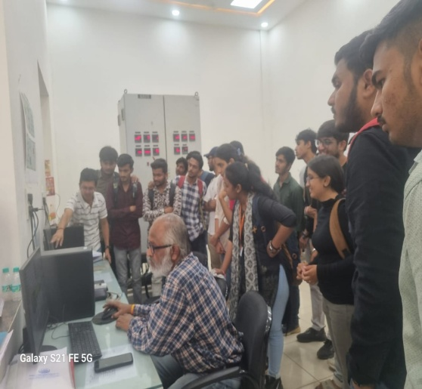
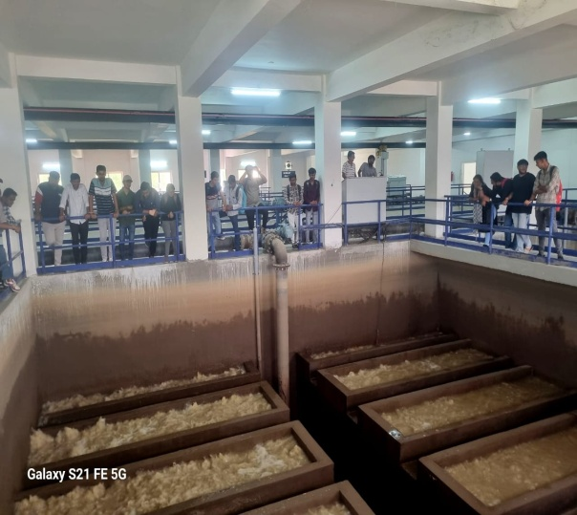 | 