Narmada dam and Statue of Unity Visit
Sardar Sarovar dam ,GERI Vadodara and the Statue of Unity in Kevadia, Gujarat, were visited by 56 students of 4th and 6th semester of GEC Gandhinagar on March 6–7, 2025 organized by Civil Engineering department under the guidance and supervision of two faculty members Prof. Shilpa Parmar and Prof. Pradeep Patel. Students had learn and explore dam site where power generation has running.
They visited river bed power house and learned how to generate power with the concept of hydropower plant with the help of hydro energy and generate electricity. Also they visited one of the hydraulic structure called Garudeshwar weir with their importance. They went to see Sardar Vallabhbhai Patel's 182-meter monument, which provided sweeping views of the Narmada River and the hills around it. They visited the Statue of unity and view of the Sardar Sarovar Dam from gallery which is a remarkable engineering achievement in India. On the second day, they went to a bird refuge called the Jungle Safari. With its combination of history, wildlife, and environmental consciousness. Students have also visited GERI campus which is known for their hydraulic structures models. The two-day trip was both educational and inspirational.
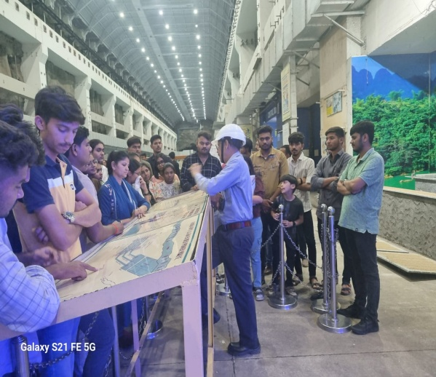 | 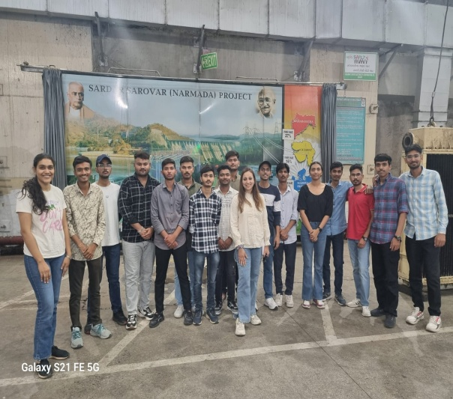
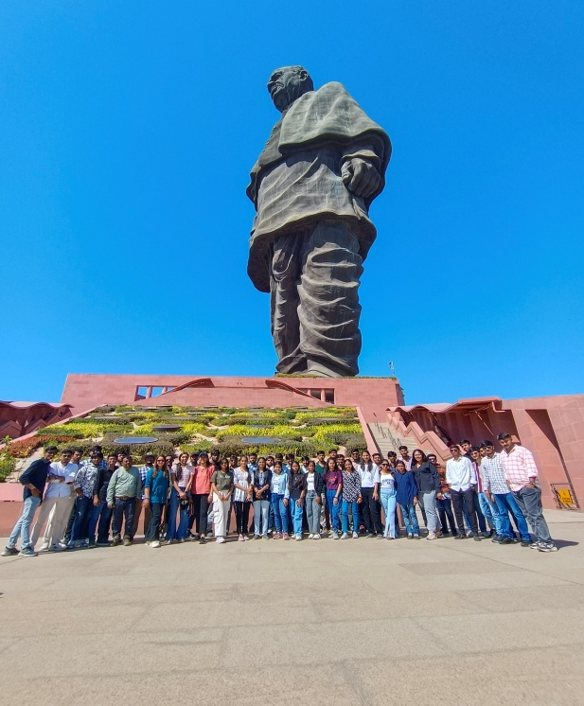 | 