PDEU – IIC VISIT REPORT

On February 19, 2025, the Civil Engineering Department of GEC Gandhinagar organized a visit to the Innovation and Incubation Centre (IIC) at Pandit Deendayal Energy University (PDEU) for 50 students, under the guidance of Prof. Shilpa Parmar. The visit offered valuable insights into innovation and entrepreneurship skill development, highlighting how the center serves as a platform to nurture entrepreneurial ventures. Students explored a curriculum that skillfully integrates theoretical knowledge with practical experience, particularly in product, industrial, and system design—with a strong focus on energy efficiency and sustainability. During the tour of various workshops, the rapid prototyping lab, equipped with advanced 3D printers, stood out as a key resource for hands-on learning. The faculty demonstrated deep awareness of current industry trends and a strong commitment to promoting innovation. Overall, PDEU’s IIC center, backed by cutting-edge infrastructure and experienced mentors, presents exciting opportunities for merging engineering with design thinking and offers meaningful potential for future collaboration in innovation and entrepreneurship.
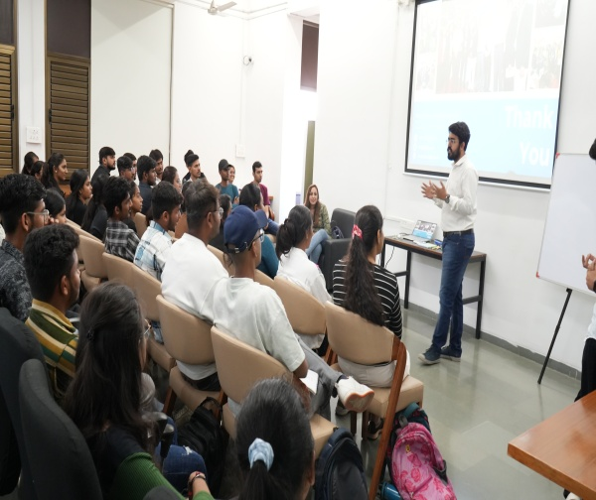 | 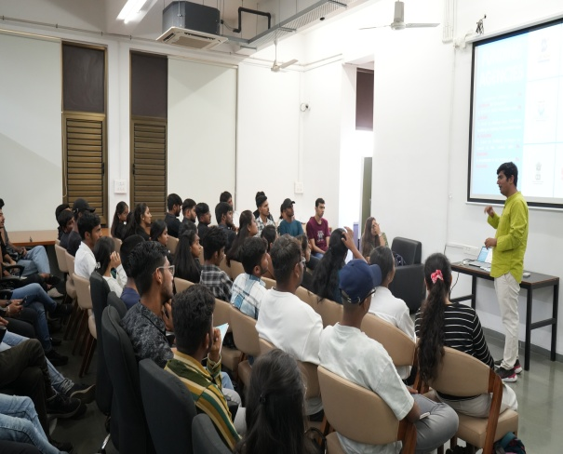
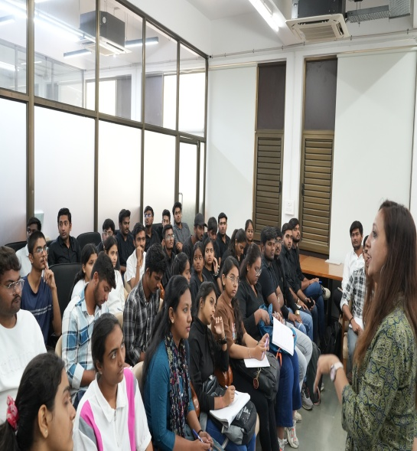 | 