Industrial Visit to Amul Chocolate Plant, Mogar and Amul Dairy, Anand

Industrial Visit to Amul Chocolate Plant, Mogar and Amul Dairy, Anand was organized by RA Faculties for Students learning in Automation field on 05-02-2026

Amul Chocolate Plant , Mogar
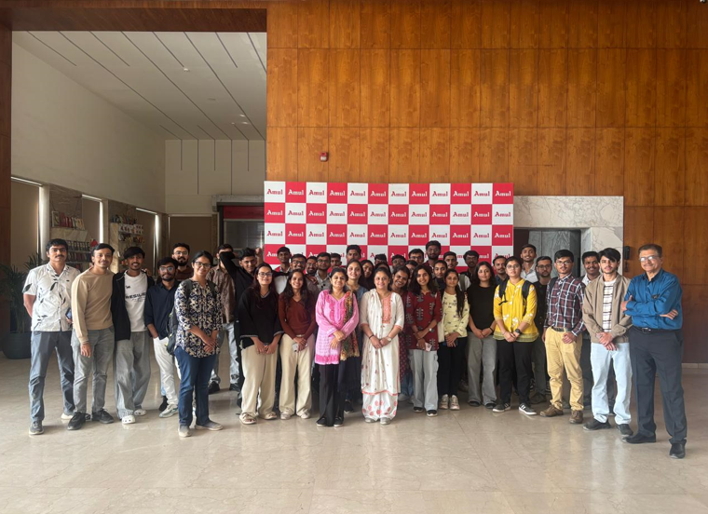
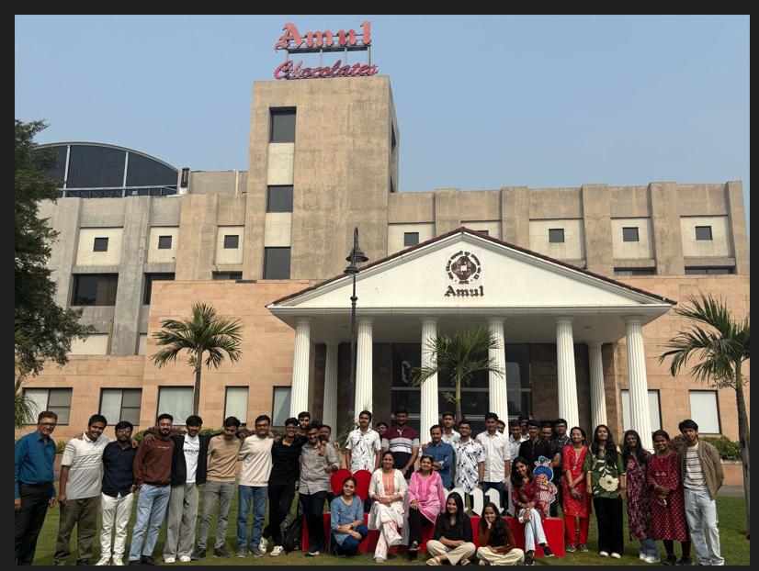
Amul Dairy, Anand
