One Day Workshop on "Recent Advances in Quality Engineering 4.0"

A one Day Workshop on "Recent Advances in Quality Engineering 4.0" was organized at RA Department for imparting students with recent knowledge related to their field and Industry which help them in Quality Engineering subjects.

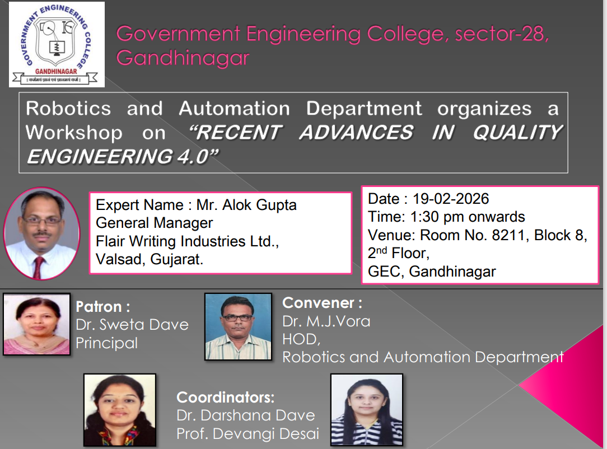

Gallery of the Event
